Tatton Wildlife Newsletter – Spring
For many people, spring is a favourite season. The daylight hours become longer as nature awakens around us. It is a great time to explore Tatton’s parkland and to witness this season of change, and hopefully to enjoy the better weather that spring has to offer.
Deer and Rare Breed Sheep
As the spring grass comes through, the daily supplementary deer feeding ceases. The red deer now moult into their russet-coloured summer coat from where they get their name and the fallow become much more speckled and brighter. The shorter hair also keeps them cooler. The males “drop” their antlers with the new ones beginning to grow immediately and they are now known to be “in-velvet”.
Our rare breed sheep will be lambing in spring. We have two separate breeds, Hebridean (pictured) and Soay. They lamb outside and are best left alone as they are hardy breeds and need no intervention. Many of them have twins and any disturbance at this time of year can lead to lambs being abandoned.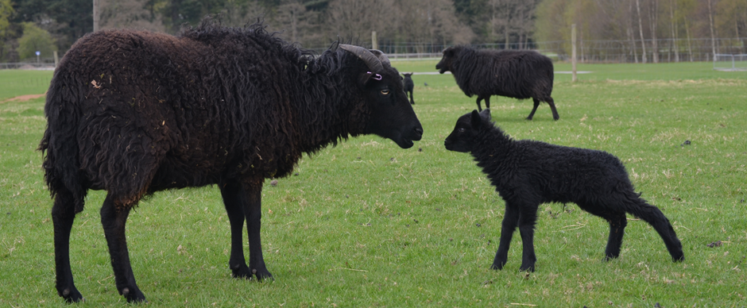
Birds
This is probably the best season to enjoy the birdlife in the park. Summer visitors will be returning, and birds are in full song. They are also in bright plumage at this time of year. Both song and plumage are used to attract a mate or to ward away rivals. Many birds are just passing through on migration. Now is the time you may see a wheatear or a whinchat as they are regulars at this time of year. Terns or even an osprey could be seen over the meres. Large numbers of Swifts and hirundines (swallows and martins) gather over the meres too as they hawk for insects.
Butterflies
The ranger team have continued to monitor Tatton’s butterfly population by doing a transect survey which is now in its fourth year. Seventeen different species were seen this year, equalling the previous best which was achieved in 2019. Some returning species this year were painted lady, comma, and small copper. This year’s most numerous species was the gatekeeper with 289 individual records. The best transect walk was on 11th July where 278 butterflies were recorded. The survey will take place again this year although numbers are predicted to be low due to the dry summer which affected the availability of succulent plants for the caterpillars.
Woodlands
Before the trees are fully in leaf, wildflowers make the most of light reaching the ground, bringing carpets of colour to many woodlands. Bluebells flower early (mid-April to late May) and within Tatton, Dog Wood provides some of the most spectacular viewing. The flowers are an important early nectar source for bees, butterflies, and other insects. The thinning and coppicing work undertaken in our woodlands has decreased the dense canopy cover and opened glades allowing wildflowers to flourish. Other wildflowers to look out for, particularly in wet woodland, include wood anemone (pictured), marsh marigold, and lesser celandine.
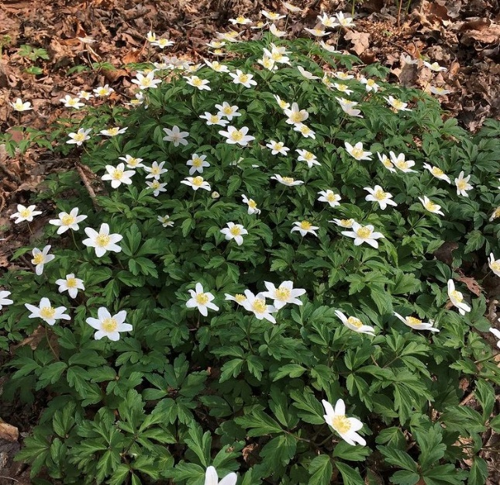
Many trees also flower in spring, with April and May being a good time to enjoy the blossom on hawthorn, plum and cherry trees which range from white through to deep pink. Although an early spring can be enjoyable for us, it can have severe consequences for wildlife. If flowers, like blossom, appear earlier, it can lead to a mismatch where hungry chicks hatch too late to feast on abundant insects that feed on the flowers. The earlier that spring arrives, the harder it is for birds to adjust the timing of their breeding to match the peak in insects.

Compiled by Tatton’s Ranger Team

